Module 5
Finance for Enterprises
by
Youth Europe Service

Project title:
Sustainable Agripreneurship
Project acronym:
SustainAgri
Grant Agreement N.:
2020-1-CZ01-KA202-078268
Programme:
Erasmus Plus KA2 Strategic Partnerships for VET – Innovation

INDEX

UNIT 1: THE IMPORTANCE OF FINANCIAL MANAGEMENT FOR A BUSINESS 3
1.1 The Financial Management 3
1.2 The importance of financial management in meeting the objectives within a business 3
UNIT 2: HOW TO IDENTIFY FINANCIAL REQUIREMENTS TO SUPPORT AN ENTERPRISE 4
2.1 How to calculate the estimated costs of activities, resources and overheads 4
2.2 The factors that affect cash flow and how to manage cash flow 5
UNIT 3: THE IMPORTANCE OF ACCURATE BOOKKEEPING TO FINANCIAL MANAGEMENT 6
3.1 How the process of bookkeeping supports financial management 6
3.2 The importance of keeping accurate financial accounts and management accounts 6
3.3 How to compare the financial performance of the business against planned performance 7
UNIT 4: FINANCIAL OPTIONS TO FUND A BUSINESS 8
4.1 How to calculate the potential costs associated with setting up and running a business 8
4.2 Advantages and disadvantages of different ways of funding a business 9
UNIT 5: HOW TO MONITOR INCOME AND EXPENDITURE 10
5.1 How to produce a forecast of income and expenditure for own business 10
5.2 How to monitor profit and loss for own business 10
6.1 How to develop a financial analysis of a business 11
6.2 Some financial analysis that can help the business performance 12

UNIT 1: THE IMPORTANCE OF FINANCIAL MANAGEMENT FOR A BUSINESS

1.1 The Financial Management
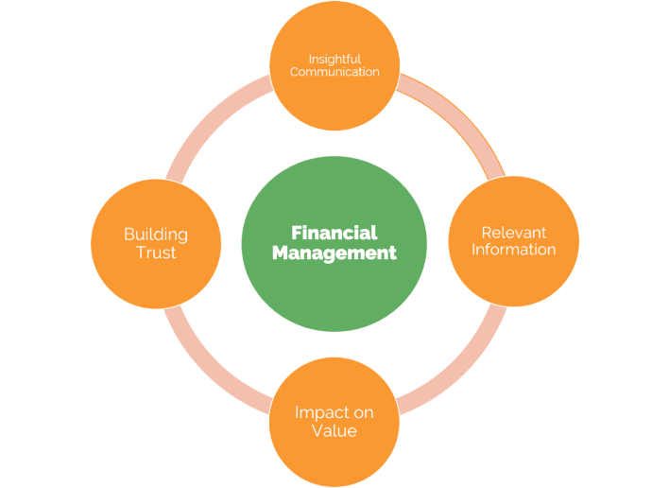
Financial Management is an activity directed to plan, organize, direct and control all the financial activities (among them, for example, there are procurement and utilization of funds of the company), so it concern the application of the general management principles to financial resources of the enterprise.
Financial management deals with making decisions on income and expenses, and the methods of collection and payment: this because everything has a cost (machinery, patents, plants, raw materials, human resources, etc.). It is not necessary to be an expert in high finance to understand that money is the basis of the survival of any company.
To keep a business running, it is important to know exactly what the available money is used for and constantly keep the flows under control: financial management, therefore, is not an isolated and stand-alone discipline, but concerns all business activities, and allows the entrepreneur to understand what most affects liquidity movements.
So financial management concerns investment decisions (on how to invest the capital), financial decisions (on how to find finances) and dividend decisions (about the division of the net profit that can be distributed to the shareholders or not distributed to be reinvested to expand the enterprise).

1.2 The importance of financial management in meeting the objectives within a business
The financial management is directed generally to have the following objectives:
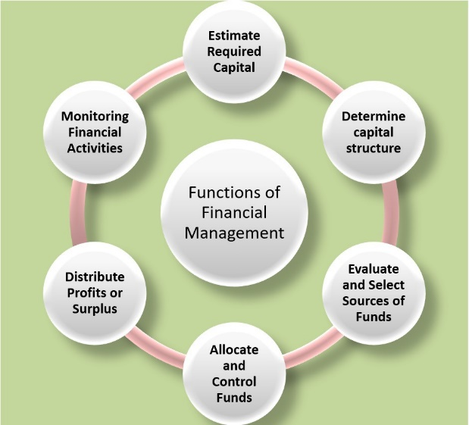
- to guarantee regular and adequate supply of funds to the company;
- to favour adequate returns to the shareholders depending from many factors such as the earning capacity, market price of the share, expectations of the shareholders, etc.);
- to ensure the best use of the procured funds;
- to warrant that funds could be invested in safe ventures to obtain an adequate rate of investment return;
- to maintain a balance between debt and equity capital.
Financial management helps:
- to improve the profitability position of the company with the help of strong financial control devices such as budget control, report analysis and cost and profit volume analysis;
- to determine the financial needs of the company, and leads to making programmatic decisions on finance;
- to make solid financial decisions in the company that affect the entire commercial operation of the business, because they have a direct relationship with marketing, production, personnel, etc.

UNIT 2: HOW TO IDENTIFY FINANCIAL REQUIREMENTS TO SUPPORT AN ENTERPRISE

2.1 How to calculate the estimated costs of activities, resources and overheads
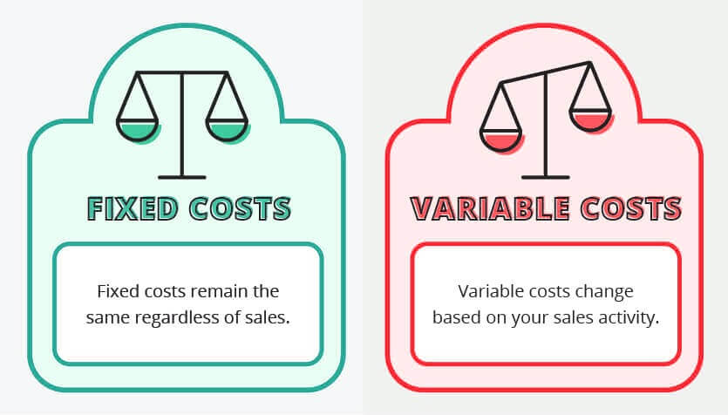
To manage a sufficiently profitable and performing business, it is necessary to periodically carry out those analyses of the business costs, which, in addition to giving a clear overview of the current economic situation, also help to identify the source of any waste, allowing it to be reduced in the shortest possible time.
The starting point is the so-called "cost classification", which is a fairly detailed analysis of all the types of costs that come into play when developing a business.
The first division to be made is that between FIXED COSTS and VARIABLE COSTS, which allows calculating the variation that costs undergo as the company's activity changes.
- FIXED COSTS: these are all those costs that do not vary as the quantities produced vary. This means that if you do not produce products or services, you will still have to cover the fixed costs anyway. What varies is therefore only the incidence of fixed costs on the overall cost of the units that are produced. Fixed costs are also called STRUCTURE COSTS since once you have determined them, those are and those remain (in the short-medium term)
- VARIABLE COSTS. Unlike fixed costs, variable costs are all those costs that vary according to the quantity of production. This means that if you produce zero products or services, the variable costs will be zero, and the company will only have to bear the fixed costs. Variable costs include the costs for the purchase of raw materials, semi-finished products, finished products. utilities, commercial costs and some administration costs.
The Total Cost will therefore be given by the sum of fixed costs and variable costs: an accurate cost analysis therefore allows us to know well also to identify the economic break-even point and therefore to better plan each business to know when it will actually produce business profits.

Nevertheless, for promoting a profitable business is also necessary to determinate what resources (people, equipment, services, and material) and the quantities of those resources are required to develop it.
For a correct planning of resources, it is necessary to define:
- what are the necessary resources;
- the availability of resources;
- the load on assets;
- possible intervention delays;
- the duration of use of the resources.
At last it is important to remember that a company has also overhead costs, that refer to all indirect expenses of running a business: these kind of expenses are not linked to the creation of a product or service, so calculating overhead costs is not just important for company budgeting but also determining how much the business should charge for a service or product to make a profit. For example, a service-based business, then apart from the direct costs of providing the service, has to incur overhead costs such as rent, utilities and insurance.

2.2 The factors that affect cash flow and how to manage cash flow
Cash flow is perhaps the most important financial quantity for the company. In fact, it is often precisely the lack of liquidity that jeopardizes the survival of the company by decreeing the success or, on the contrary, the crisis or even the failure of its activities.
Managing cash flow is an important challenge for all business especially the smaller and younger ones.
It is not uncommon, in fact, for a company, while generating large profit margins, to find itself in shortage of liquidity, therefore unable to pay taxes, suppliers or employees due to negative cash flow. Optimized cash flow management is, therefore, one of the main objectives that a company must aim for.
Cash flow indicates the positive or negative changes in the company's liquidity that occur in a given period of time, generally a year. It is also called primary flow after taxes. In practice, it is obtained as the difference between the total cash inflow and the total cash outflow and represents the amount of cash that the company owns at a given time in its life.
So cash flow is a measure of the company's ability to finance itself without having to resort to debt. In practice, cash flow analysis is one of the main tools for controlling the company's financial management which aims to optimize treasury management by containing financial charges.
If the company is able to estimate cash flows at a certain date with a good approximation, it will be able to negotiate any hedges necessary to cover liquidity deficits in time and, perhaps, will also be able to foresee loans. more remunerative for current liquidity, while still guaranteeing its financial solvency even in the face of unforeseen events.
Cash flow is obtained by adding non-monetary costs to the profit or loss for the year (depreciation of machinery and equipment, provisions for future risks, employee severance indemnities or the write-down of receivables) and subtracting non-monetary revenues such as taxes advance payments or the revaluation of equity investments.
Business management must aim at the goal of a positive cash flow. With the right liquidity, in fact, the company is able to pay taxes, suppliers and other creditors, as well as employees, without problems and, perhaps even make additional investments to support business growth. To manage cash flows more effectively, there are some tricks that allow you to improve company liquidity by setting careful cash flow planning.
The most important cash flow management techniques are:
1) Implement effective risk management strategies;
2) Better manage payment extensions
3) Periodically update the budget forecasts
4) Carefully calculate the depreciation of machinery and equipment and inventory
5) Equip yourself with software to manage cash flow in advance

UNIT 3: THE IMPORTANCE OF ACCURATE BOOKKEEPING TO FINANCIAL MANAGEMENT

3.1 How the process of bookkeeping supports financial management
First of all, it is important not to confuse accounting and financial management, because, although both are related accounting skills, they are profoundly different even though both are fundamental in guiding the business organization to success.
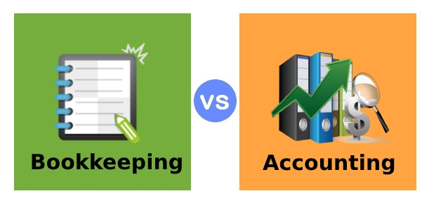
Bookkeeping can be defined as the process aimed at collecting and recording any event of an economic or financial nature that occurs within a company, the primary purpose of which is the preparation of financial statements.
Bookkeeping is about documenting various transactions, both inside and outside the organization and it is generally considered to be the compilation of financial statements that can be used by the freelancer or small business owner to conduct sound financial management.
Financial management, on the other side, refers to focusing on transactions that have already taken place and ensuring they are correct and considering ways to improve them in the future. Financial management deals with financial statements, which are used to consider things like budgets, profits, and overall financial controls
Accounting aims not only to avoid heavy penalties but above all to improve the management of the business and to allow the entrepreneur:
- Real-time expense control;
- The timely identification of any concessions and contributions;
- Optimization of the tax burden;
- Better management and simplified control of the company.

3.2 The importance of keeping accurate financial accounts and management accounts
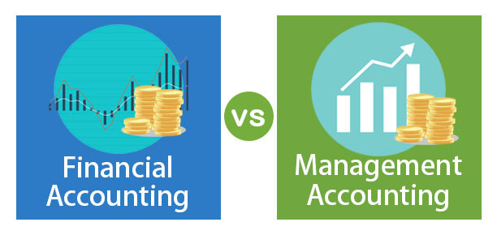
Financial accounts concern those assets that are payment instruments such as money, checks, bills of exchange, availability in the bank, debts and credits. Their value is expressed on the security (on the banknote, on the check) and they do not require evaluation. They are payment instruments, it was said, and are used to purchase the goods and services (production factors) that the company uses to produce.
Management accounts are financial reports produced for the business owners and managers, generally monthly or quarterly, normally a Profit & Loss report and a Balance Sheet. In principle they are similar to Year-End accounts but are less formal and are personalised to the reader's requirements.
It's really important that the business accounts are accurate and up to date: they have to be backed up with full and detailed records of all business income and expenditure, such as receipts, invoices and purchase orders, payments in and out, etc.
Following careful record-keeping procedures can also help the business with tax returns and to prevent fraud or theft. Using a good record-keeping system will help to:
- track expenses, debts and creditors
- apply for additional funding
- save time and accountancy costs
- pay tax, accurately and on time, avoiding penalties
- apply for and receive the correct amount of benefits or credits
While starting a new business it is essential that you get a proper record keeping-system in place immediately.
It is possible to use various storage methods to:
- show all information contained within a document
- allow information to be presented in a readable format
- keep all original documents,
- keep documents which show that tax has been deducted.
Detailed and up-to-date records help the company to comply with tax legislation as it can be penalised for:
- not keeping adequate records
- failing to keep records for required periods of time
- inaccurate tax returns
- etc.

3.3 How to compare the financial performance of the business against planned performance
Every company is well aware that most aspects of business do not go exactly as planned: this is a sad reality in all businesses, so it is important to analyse and investigate the difference between planned performances and real ones.
Thanks to company indicators, management can not only measure company phenomena over time and space (with respect to the competition, the sector, etc.), but can also plan and program company activities (defining measurable objectives in the short and medium term ), measure the discrepancies (gaps) between expected objectives and results obtained, and take action necessary to correct the gaps, or can manage the company methodically.
There are two aspects with which it is possible to observe company performance from a strategic point of view:
1) As result profiles (not exclusively of an economic-financial nature). This first aspect leads to the identification of a system of measures of effectiveness, efficiency and cost-effectiveness which, on the basis of strategic guidelines and pre-established objectives, is able to detect the company's ability to manage the critical variables that underlie the competitive advantage. .
2) Like Trend. The temporal aspect leads to a prospective vision that starts from the results achieved and focuses on the management conditions that are projected into the future and which constitute the prerequisites for maintaining and improving performance.
The measurement of the performance of business activities and processes requires the definition of a system of indicators that makes it possible to represent, in a unitary and prospective framework, the company's ability to pursue its short, medium and long-term objectives.
It is not a system of measures that capture only the results achieved, therefore according to a static analysis perspective, but which is also capable of highlighting the company's ability to adapt to changes in the external environment, according to an analysis perspective. dynamic.
There are different types of indicators that can be traced back to as many models, the most famous ones are:
Those most famous are:
- Critical Success Factors (CSF), used to define critical business areas and define strategic indicators;
- Key Performance Indicators (KPI), to identify the critical performance of business processes, is oriented towards operational control;
- Management Accounting, to build the infrastructure of economic and equity indicators for management control;
- Balanced Scorecard (BSC), summary of the previous methods.

UNIT 4: FINANCIAL OPTIONS TO FUND A BUSINESS

4.1 How to calculate the potential costs associated with setting up and running a business
One of the most common problems that cause new business failures is not having enough cash to meet expenses, especially in the first year of starting the business.
To reduce this risk it is always necessary to identify and plan for potential business costs.
There are start-up costs associated with starting a business, such as:
- market research;
- preliminary accounting;
- legal advice;
- tenancy and lease bond;
- transfer duty;
- lease agreement advice;
- telephone and internet installation;
- licences and insurance;
- entry in the commercial register;
- notary;
- power connection;
- signage;
- software;
- vehicles;
- initial marketing;
- equipment and fittings purchases;
- staff costs and wages;
- raw materials or stock purchases.
Of course, the exact start-up costs will depend on the type of business and the sector of industry/services in which the company is going to be established and also the amount of costs in the different categories can be different depending from the business (an internet business, for example, normally has less costs of locations than a restaurant).
Some suggestions to calculate the potential costs of a new business are the following:
- prepare always a business plan that can express all the possible costs the business could face to start and run;
- check the financial statements of any company it is possible to find in the same sector of business, especially competitors and market leaders;
- talk to many businessmen and trade associations as possible, asking questions and getting advice and suggestions from mentors or experts;
- calculate ongoing and one-time costs, identifying a possible budget to not find problems in the future;
- look around to see if there are possible support and other incentives to help new businesses (also asking the help of an accountant, financial adviser, or other professional);
- attend all possible free business webinars where you can find suggestions and new information from business advisers;
- set up realistic expectations for your business;
- add 10% of extra costs on top of your total costs to cover any miscellaneous and unforeseen expenses.
Once followed the above steps, it is also possible to enter the projected monthly costs and one-off expenses into a start-up costs software, that will automatically calculate possible subtotal and total, as well as showing the percentage of the cost for each item: this thing will be very useful because some costs may not be relevant to the chosen business or it may need to add other items.

4.2 Advantages and disadvantages of different ways of funding a business
Starting a new business, it is probable that it will be necessary to invest at least some of the personal money because it can be difficult to obtain it only from a bank or from possible investors, so the easiest and most cost-effective way to finance own business is to use your personal savings.
However, this can be risky, and it may not have enough to cover all the needed funding, so it is always a good solution:
- getting a mortgage by banks and lenders;
- obtaining financing from friends and/or members of the family;
- getting an unsecured loan, or borrowing on credit cards;
- selling possessions or assets;
- finding possible public funds.
But it is always necessary to be very careful before borrowing any amount of money and try to match the financing to own business needs because having too much money can create other problems (for example, using credit cards for long-term expenditure can be very expensive, while some loans can be inflexible and have the effect to oblige to pay interest over many years).
Of course, a self-financing of own business has the advantage of not spending time trying to secure other forms of funding from investors or banks, but, on the other side, it has the disadvantage of may put a strain on own family and personal life because, for example, there could be not enough money left over to cover the normal living costs and if your business should fail, it could be possible to lose own home and other personal possessions.
Many investors and venture capitalists can also provide mentoring and networking opportunities for the possible business while, without them, the entrepreneur has to develop his own contacts and mentoring opportunities.

UNIT 5: HOW TO MONITOR INCOME AND EXPENDITURE

5.1 How to produce a forecast of income and expenditure for own business
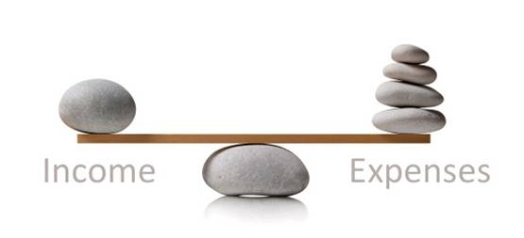
Forecasting business revenue and expenses during the startup period is really more art than science because nothing is sure and all is just a provision that can happen or not but, in any case, realizing important, proper financial forecasts will help to develop operational and staffing plans and this will help to make the business a success.
To produce a forecast of income and expenditure for own business it could be important to follow the rules indicated below:
- Start always to calculate the expenses, not the revenues, because, in the startup period, it's much easier to forecast expenses than revenues. In this calculation, it is necessary to remember that the most common categories of expenses are:
- Fixed Costs/Overhead, such as:
- Rent
- Utility bills
- Phone bills/communication costs
- Accounting/bookkeeping
- Legal/insurance/licensing fees
- Postage
- Technology
- Advertising & marketing
- Salaries
- Variable Costs, such as:
- Cost of Goods Sold (Materials and supplies, Packaging, etc.)
- Direct Labor Costs (Customer service, Direct sales, Direct marketing, etc.)
- Double the estimates for advertising and marketing costs since they always escalate beyond expectations.
- Triple the estimates for legal, insurance and licensing fees since they are very hard to predict without experience and usually exceed expectations.
- Keep track of direct sales and customer service time as a direct labour expense during the start-up period because this expense will increase when the business will have more clients.
- Make a forecast of revenues using both a conservative case (with low price point, various marketing channels, no sales staff, etc.) and an aggressive case creating, in this case, a set of ambitious forecasts and developing innovative ideas of business (with the low price point for the base product and a higher price for a premium product, have a marketing manager, have salespeople paid on commission, etc.).
- Check the key ratios to make sure that the projections of income and expenditures are correct.

5.2 How to monitor profit and loss for own business
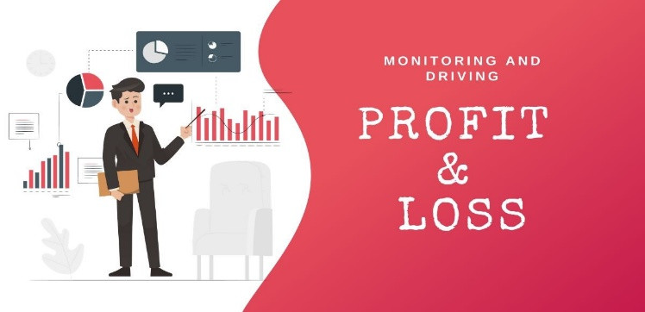
In order to assess the performance of a business, there are many critical questions that need to be answered and it could be useful to realize regular financial monitoring, that plays an important role in ensuring that strategic decisions are made in a timely manner and that the business growth plan is adhered to.
The financial monitoring should be realized developing the following actions:
- Prepare the key financial statements of the company that are the balance sheet and the profit/loss statement. These statements, that give an overview of the financial health of the business, are not only vital indicators of the performance of the business, but they are also required statutorily.
- Prepare Debtors Trial Balance to keep track of irregular accounts and to follow up the customers who still owe money to the company.
- Prepare and maintain accurate inventory records, which will clarify how much stock was purchased, how much was used for making the final products, how much of it went waste, whether any equipment has gone missing at any point of time or if the company needs to purchase more raw materials.
- Prepare Working Capital Statements and Financial Ratios to understand how many assets they have, as compared to their liabilities, and how many assets they can convert quickly to cash.
- Prepare Fund and Cash Flow Statements that are vital reports for a business because they indicate how much liquid cash is coming into the business.
- Develop an Analysis of Overheads to find possible point out weak business areas.
- Develop an Analysis of Marketing Expenses to assess the financial performance of the business.
- Develop an Analysis of Human resources to understand how they impact the business.
- Prepare daily, weekly, monthly and yearly dashboards to keep all stakeholders informed of the company's financial progress.
- Develop Competitive analysis to compare the financial indicators of the company with those of competitors.

UNIT 6: HOW TO CONDUCT A FINANCIAL ANALYSIS

6.1 How to develop a financial analysis of a business
Financial Performance is an important aspect of finance risk management and, in a larger sense, refers to the degree to which financial objectives being or has been accomplished.
It permits to verify of the results of a firm's policies and operations in monetary terms and it is used to measure overall financial health of a company over a given period of time and can also be used to compare similar firms across the same industry or to compare industries or sectors in aggregation.
Financial analysis is an important tool for managing corporate financial resources and is different from other types of analysis in many respects because it is based first of all on the accounting of the company compared to the economic context.
Its goal is to better understand what are the strengths and weaknesses of the company studied, testing the solidity of a company starting from its financial results.
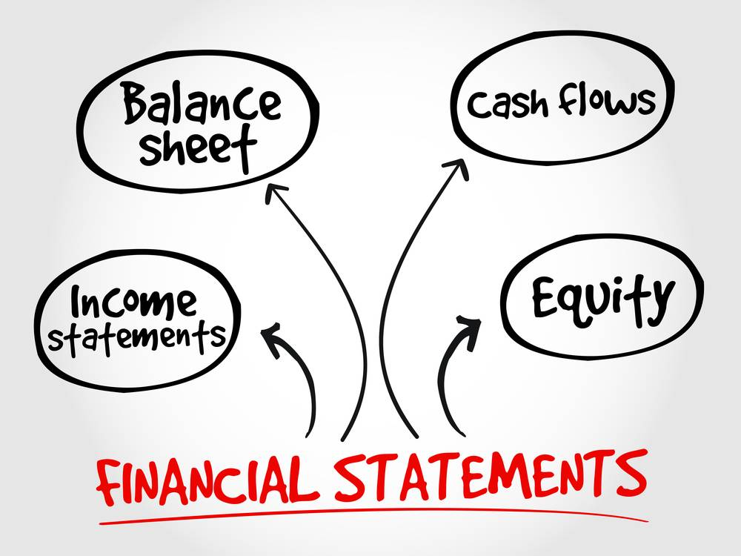
This study serves to determine as accurately as possible the possible business evolutions, allowing to evaluate their solvency and to determine their real value in order to invest in its securities.
To carry out a complete and effective technical analysis, it is necessary to take into account at the same time pure financial data and other data that can influence the performance of the securities, such as the business sector and prospects, depending on the economic context.
Financial analysis is also a primary tool for protecting oneself from non-transparent behavior of financial institutions, controlling incorrect banking behaviour and bordering on usury.
It involves the use of the financial statements, therefore a collection of data that is organized according to logical and consistent accounting procedures with the aim of making the financial aspects of the company understandable.
It may show a position of a period of time as in the case of a Balance Sheet, or may reveal a series of activities over a given period of time, as in the case of an Income Statement.
The financial statements are comprised of four basic reports, which are:
1) Income statement, that presents the revenues, expenses, and profits/losses generated during the reporting period.
2) Balance sheet that presents the assets, liabilities, and equity of the entity as of the reporting date so in a specific point in time.
3) Statement of cash flows that presents the cash inflows and outflows that occurred during the reporting period.
4) Statement of retained earnings that presents changes in equity during the reporting period.
However, financial statements do not only reveal information related to the financial operations of a firm, but they furnish also useful information on profitability and financial soundness of a company helping possible investors and stakeholders to take their investment decision.

6.2 Some financial analysis that can help the business performance
Ratio analysis is a good way to evaluate the financial results of a business in order to gauge its performance. 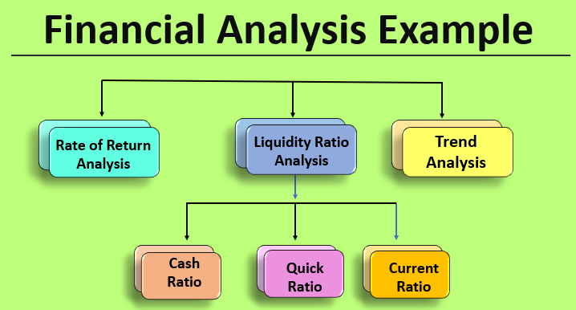
The most famous 3 financial analysis examples are:
  - Liquidity Ratio Analysis, which is a measure of the timeliness with which a company should be able to clear out its imminent liabilities. It involves
a) Cash Ratio, which compares the amount of cash to the immediate short term liabilities.
b) Quick Ratio, which is the measure of the cash and the future cash to be received (receivables from debtors) to repay the current liabilities that the firm has, involving assets that can be converted into cash within 90 days. This ratio gives an indication of the ability of the firm to cover its liability obligations without resorting to the long term assets.
c) Current Ratio, which measures the current assets that a firm has against the payment of the current liabilities
  - Trend Analysis, which indicates the performance of a given variable over a period of time to find out the various features, permitting to predict the future course of action and weaving methods around it considering such a trend to continue in the near future.
  - Rate of Return Analysis, which is generally used in the case of a capital purchase decision-making process (the rate of return is, in fact, the measure of the increase in returns that the new asset will provide over the cost incurred on it). This analysis could be performed at two stages:
a) Pre-purchase, which indicates the expected returns that an asset would bring over a period of time.
b) Post-purchase, which permits verifying what the rate return has generated to see if it was convenient or if, in the future, it is better to find alternative solutions.

