Tool: Understanding Sustainability Criteria

Purpose:
- To understand the importance of defining a problem
- To examine the implicit and explicit assumptions, values, priorities, etc. that influence the process of problem definition
- Expose and reflect on the values and criteria that we use to define notions of sustainability
- Practice using communication and persuasion

Description:
Defining the problem is a first step in any problem-solving activity. However, the way that problems are defined depends on the values and parameters - the CRITERIA - that we use.
This is a group activity in which you are asked to push yourselves to think more critically about your understanding of sustainability and the (sometimes implicit) criteria you use to decide whether something is sustainable or not.

Step 1. Ranking Products. With your group, choose six of the available items and rank them according to which you believe are more or less sustainable.

Step 2: Identifying Sustainability Criteria
For example, if you selected a package as being more sustainable because it was made out of cardboard because you were assuming that cardboard is easy to recycle, then they would describe that sustainability criteria in terms of efficient recycling. List your group’s sustainability criteria (no need to divide the criteria by product).

Step 3. Identifying Themes. As a full class, each group will list the different criteria that they came up with. Then identify themes within the list of criteria.

Step 4. Discussion - Defining sustainability
Discussion: How to the criteria and themes established in Steps 2 and 3 relate to the „three "pillars" of sustainability?

Step 5. Reranking products. Go back and look at your original rankings. Based on the class discussion, would your rankings and/or the reasons you give for those rankings change? Discuss this with your group members and complete a second ranking table.

Step 6. Group presentations. With your group prepare a 3 minute presentation on your original ranking criteria, if and how these criteria changed in your second ranking, and a justification for these changes (or lack of them).

Step 7. Expanding sustainability criteria themes. As a group repeat Step 3 to determine if additional criteria and themes have emerged and create a master list of the different criteria that may be relevant to sustainability.

Step 8. Discussion - Another definition of sustainability.
The three categories are not necessarily "pillars" but might be embedded in one another. While the society cannot survive without a healthy natural environment, and an economy cannot survive without society. Compare Picture 1 and Picture 2.

Nothing can be measured (evaluated) without criteria. Start with everyday items, try to get more into the problem, do not worry about changing you point of view!

Understanding Sustainability Criteria – group activity

Picture 1.

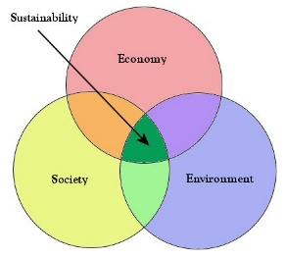

Picture 2.
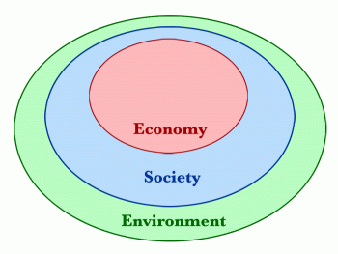

Table 1.
Product Description | Why did you choose this product?
1. (Best)
2.
3.
4.
5.
6. (Worst)

List of sustainability criteria:

Table 2.
Package Description | Original Ranking | What are your decision criteria for ranking this product?
1.
2.
3.
4.
5.
6.

