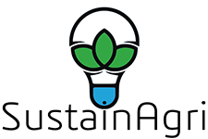

Trainer Guide:
Module 3: Sustainability and Business Improvement

How to Use the Trainer Guide

The Trainer Guide has been designed to support the delivery of the SustainAgri course for learners as a one-day course. The course can be amended enabling it to be delivered in a variety of formats including:
- 2 x ½ day course
- Series of mini 2-hour sessions
- Webinar and/or blended learning course

The Trainer Guide explains how to use the PowerPoint trainer slides. The files can be edited and branded to meet your organisation and target group needs.

The course includes suggestions for a variety of team-based and individual activities – these can be edited and modified according to the trainer’s preferences and delivery model.

Slide 1:

Notes: Welcome learners and introduce yourself.
This course aims to introduce participants to the SustainAgri course. During the course, there is the option for participants to complete a series of activities. Participants will learn how to improve the sustainability, efficiency, and performance of an enterprise to create growth and added value

The course is practical and interactive. It has been designed to enable the trainer to run the course as a one-day workshop-style event, but it can also be delivered as an online webinar or a series of two-hour mini workshops over a period.

Introduce the trainers - possibly setting out the trainer’s qualifications, experience, and credentials for running the course.

Slide 2: | 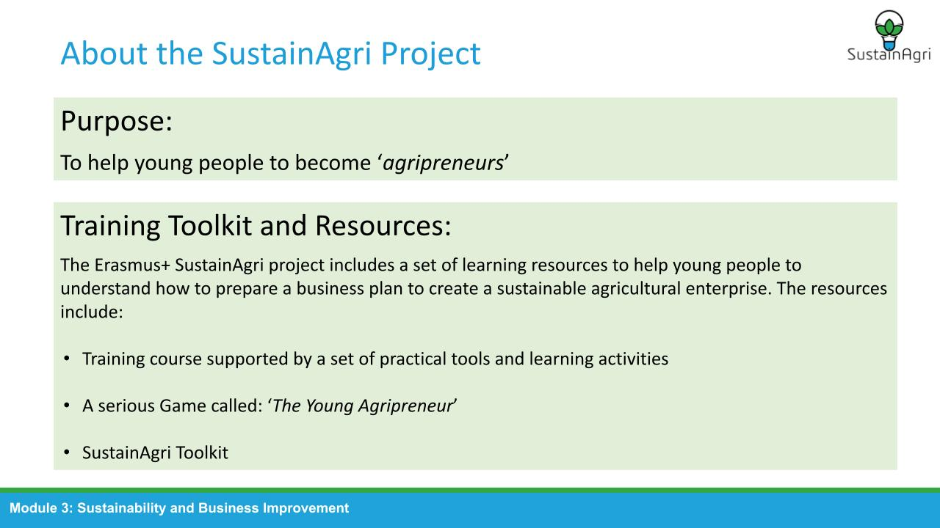

Notes: Outcomes
Explain the purpose of the SustainAgri project and provide an explanation of the training toolkit and resources that have been produced to help participants develop a sustainable agricultural enterprise.

Slide 3: | 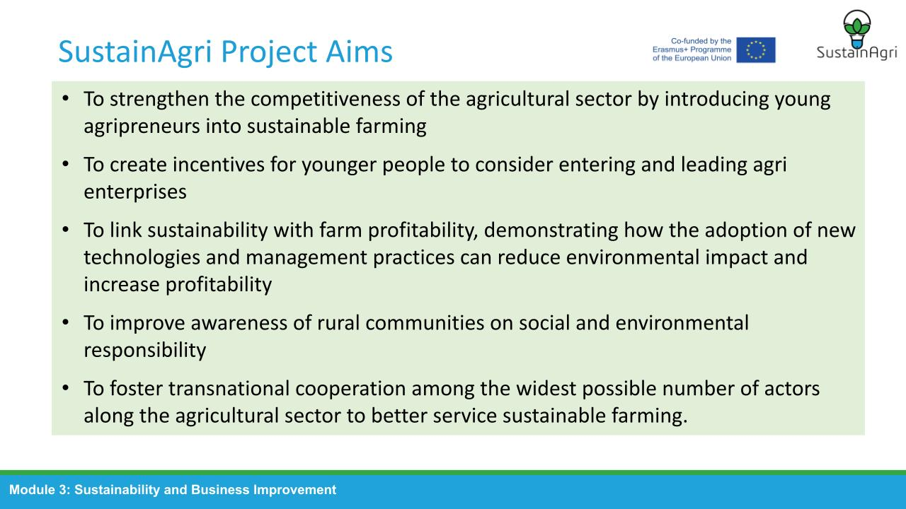

Notes: Project Background
Introduce the background and purpose of Erasmus+ projects and then move on to introduce each of the partners involved in the long-term outcome for SustainAgri: to equip young entrepreneurs with the required knowledge to embrace farming and transform it into a sustainable entrepreneurship.

Discuss the aims and outcomes of the course which can be adjusted to reflect your delivery methodology and your participant’s needs. Discuss purpose and structure of the SustainAgri project

Slide 4: | 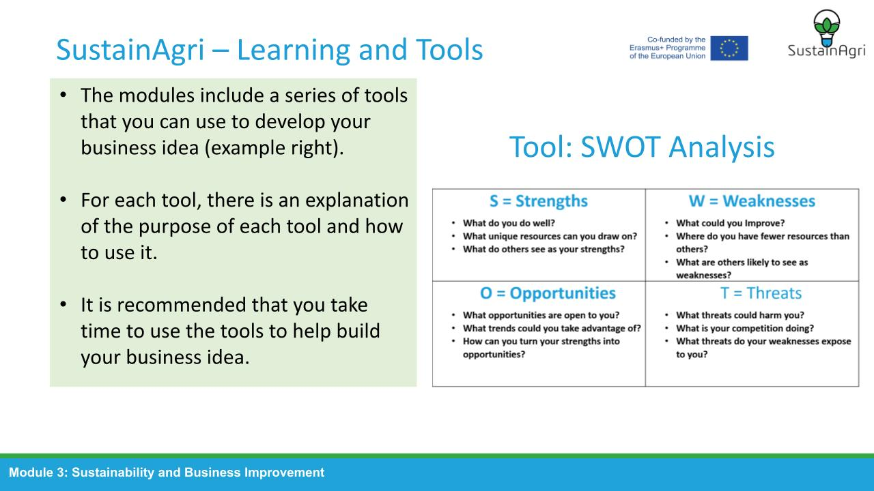

Notes: SustainAgri Tools
Discuss the tools that will be made available and how they can be used. Provide an example of a tool that can be used to .

Slide 5: | 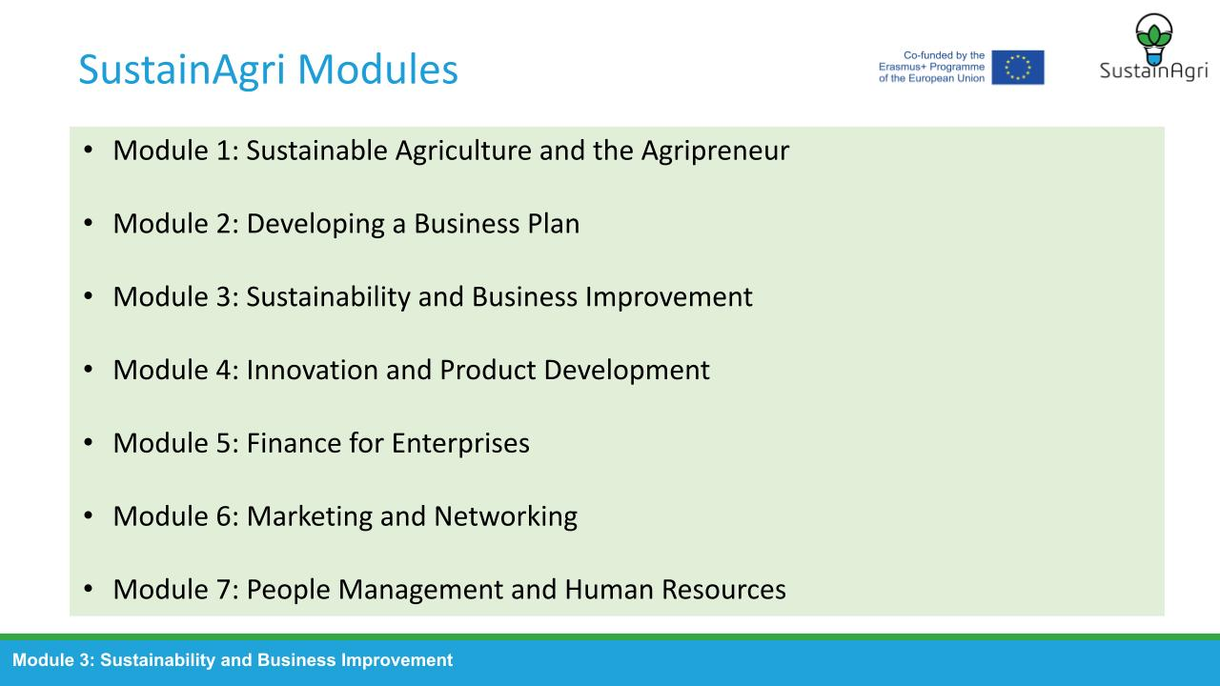

Notes: Discuss Module Content
Explain that each of the seven modules have been designed to support the development of a sustainable agricultural enterprise. Explain that this workshop will focus on Module 3: Sustainability and Business Improvement.

Slide 6: | 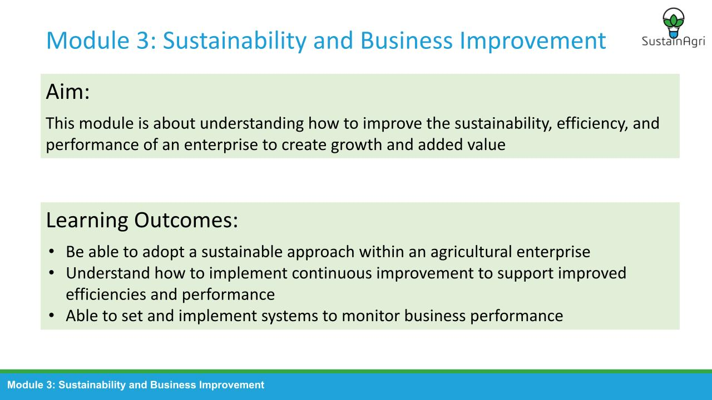

Notes: Discuss Module Purpose
Module 3: This module is about understanding how to improve the sustainability, efficiency, and performance of an enterprise to create growth and added value. Specifically, you will learn to:
- Be able to adopt a sustainable approach within an agricultural enterprise
- Understand how to implement continuous improvement to support improved efficiencies and performance
- Be able to set and implement systems to monitor business performance

Slide 7: | 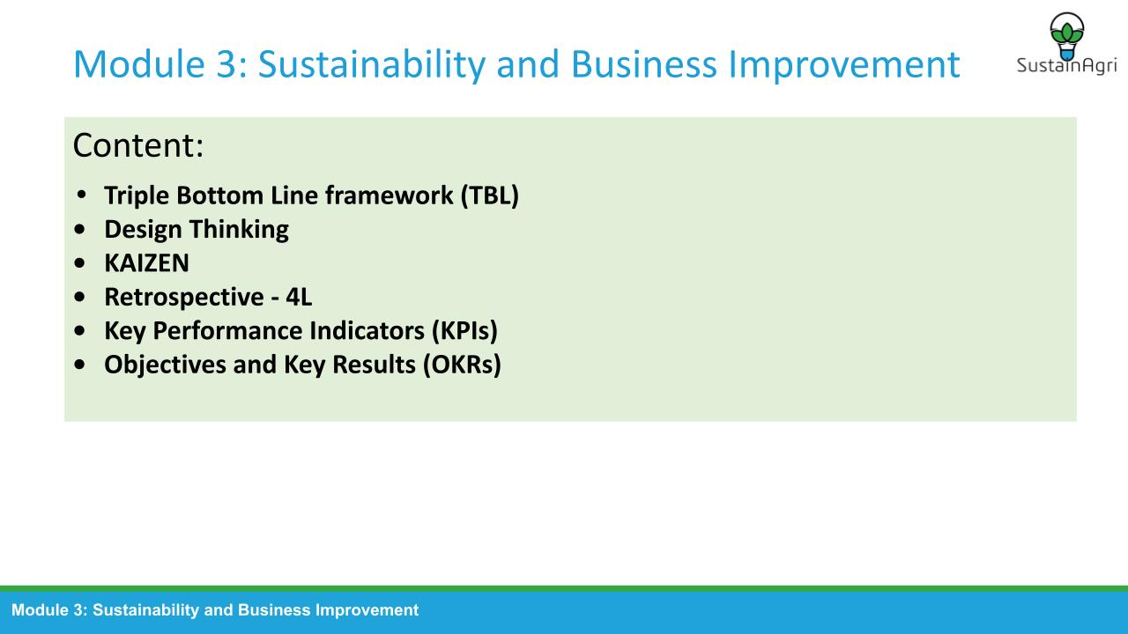

Notes: Discuss Module Content
- Triple Bottom Line framework (TBL)
  - Describe how agricultural enterprises can implement sustainability strategies
  - Explain the concept of and implementation of ‘circular agriculture in an enterprise
  - Prepare a plan to implement a sustainability plan within an agricultural enterprise
  - Explain to concept and use of the three pillars of sustainability model
- Design Thinking
  - Explain the concept of continuous improvement
  - Explain the use of problem solving and root cause analysis to support continuous improvement
- KAIZEN
  - Describe the principles for the deployment of Kaizen
  - Explain the concept of continuous improvement and Kaizen
- Retrospective - 4L
  - Explain the use of problem solving and root cause analysis to support continuous improvement
  - Use of tools and techniques to monitor and improve performance, efficiency, and productivity
- Key Performance Indicators (KPIs)
  - Explain how to set quantifiable targets and objectives linked to business plans
  - Prepare and implement systems to monitor a set of key performance indicators (KPIs)
  - Use of tools and techniques to monitor and improve performance, efficiency, and productivity
- Objective and Key Results (OKRs)
  - Explain how to set quantifiable targets and objectives linked to business plans
  - Prepare and implement systems to monitor a set of key performance indicators (KPIs)
  - Use of tools and techniques to monitor and improve performance, efficiency, and productivity

Slide 8: | 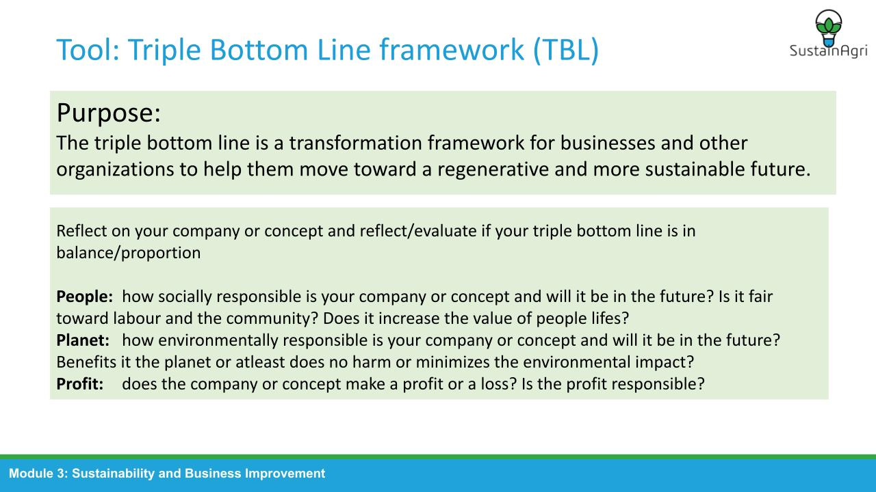

Slide 9: | 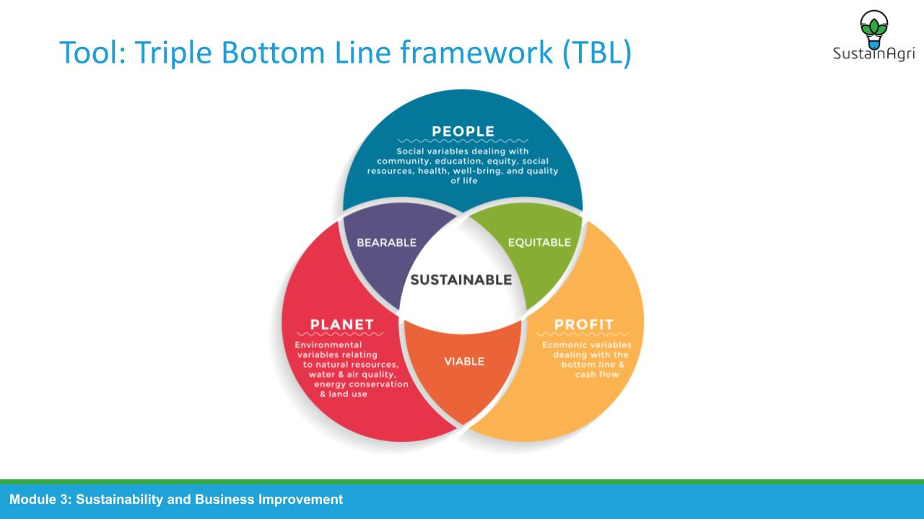

Notes:
Triple Bottom Line can be understood as a triangle where all three points must be in balance with each other. The Triple Bottom Line forms the basis for corporate social responsibility. Each dimension; the People dimension (social), the Planet dimension (environmental) and the Profit dimension (economic) should be fully integrated into the organization's operations.

In addition to the balance between the three dimensions at the present time, it is also important that the balance between people, planet and profit can be ensured in the future. That way the current quality of life can also be ensured for future generations. The three pillars develop independently of each other, but can overlap. three shear zones. These are zones where the different bottom-lines overlap. In these zones, tension exists between two bottom-lines.

Slide 10: | 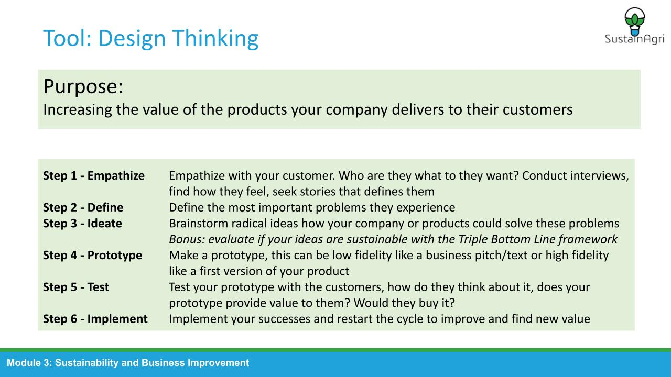

Slide 11: | 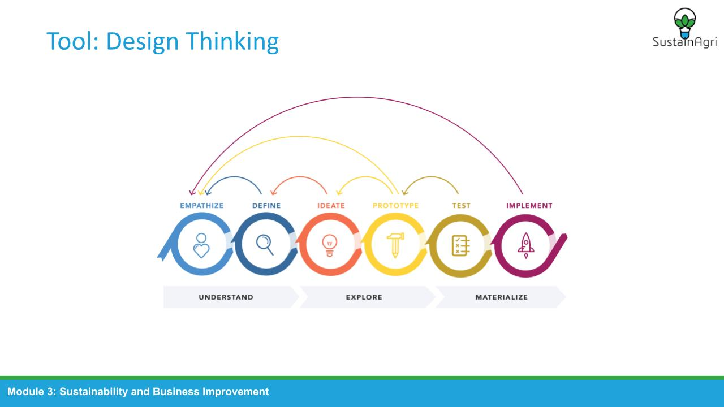

Notes:
Design thinking is a way of creative problem solving in which you have to find the right balance between analytical and intuitive thinking. It is important that the solution to the problem is human-centered. Design thinking balances analytical thinking and intuitive thinking, enabling us to combine existing knowledge and create new knowledge. It is about combining analytical and intuitive thinking and the interplay of both ways of thinking.

Our understanding of design thinking has evolved tremendously over the past decade. Design thinking arose because designers considered their way of thinking and working to be of added value for questions that do not directly require creative expressions. Design thinking is now also used a lot, for process optimization, in work task allocations and in optimizing product journeys.

Slide 12: | 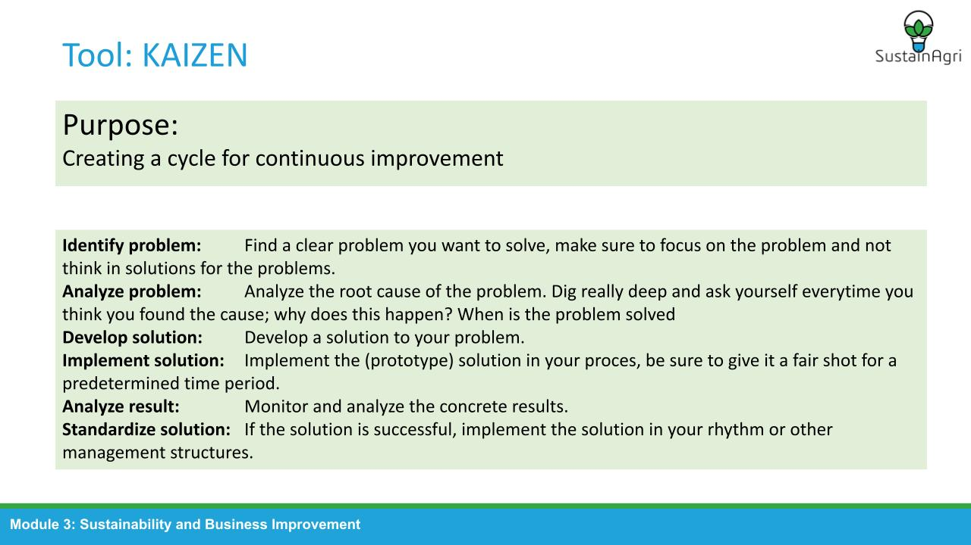

Slide 13: | 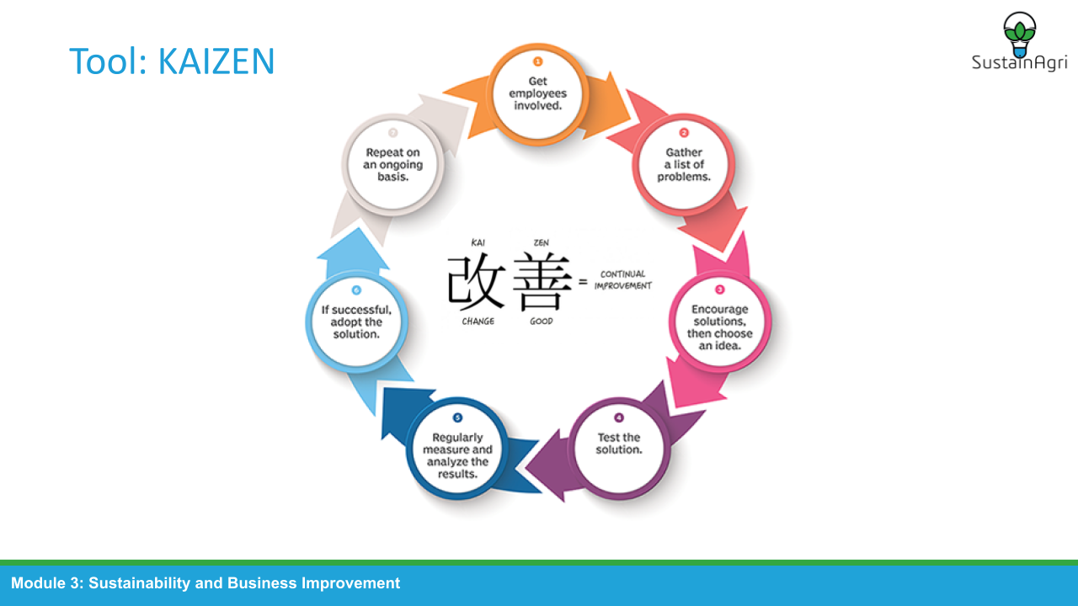

Notes:
Kaizen is a business philosophy for process improvement and originates in Japan. It puts an organization in a state of control and continuous adaptation. Kaizen is based on the idea that small continuous positive changes can produce big improvements. Kaizen was invented by Toyota just after the 2nd World War. Sakichi Toyoda, founder of Toyota, is the spiritual father of Kaizen. He was always looking to improve his product. His hunger for improvement was never satisfied.The Kaizen principle is meant to be a culture rather than a stand-alone roadmap or model.

Example of Toyota:
https://www.youtube.com/watch?v=F5vtCRFRAK0

Slide 14: | 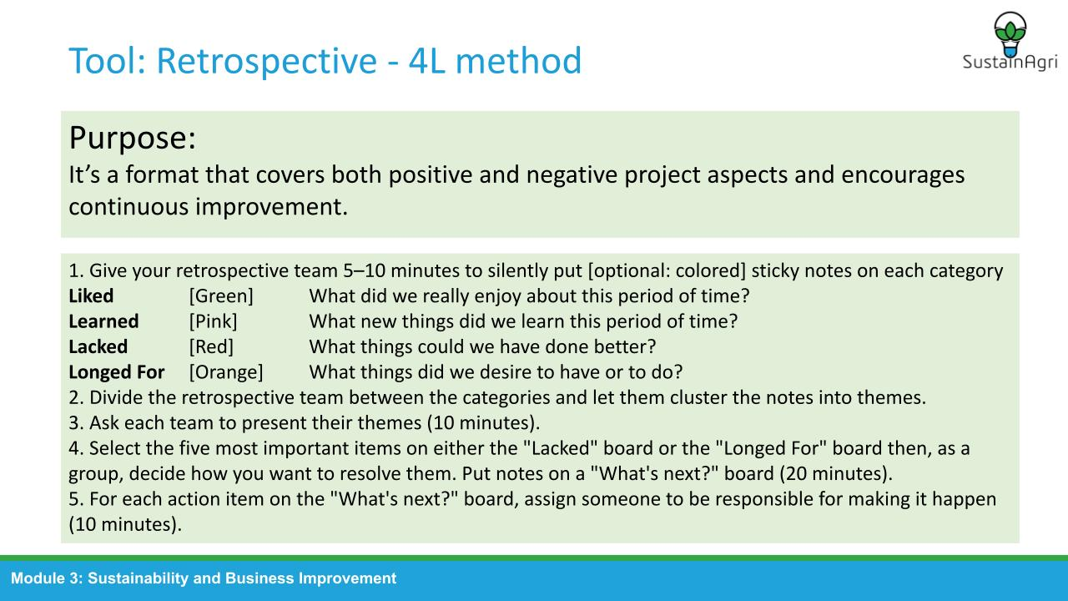

Slide 15: | 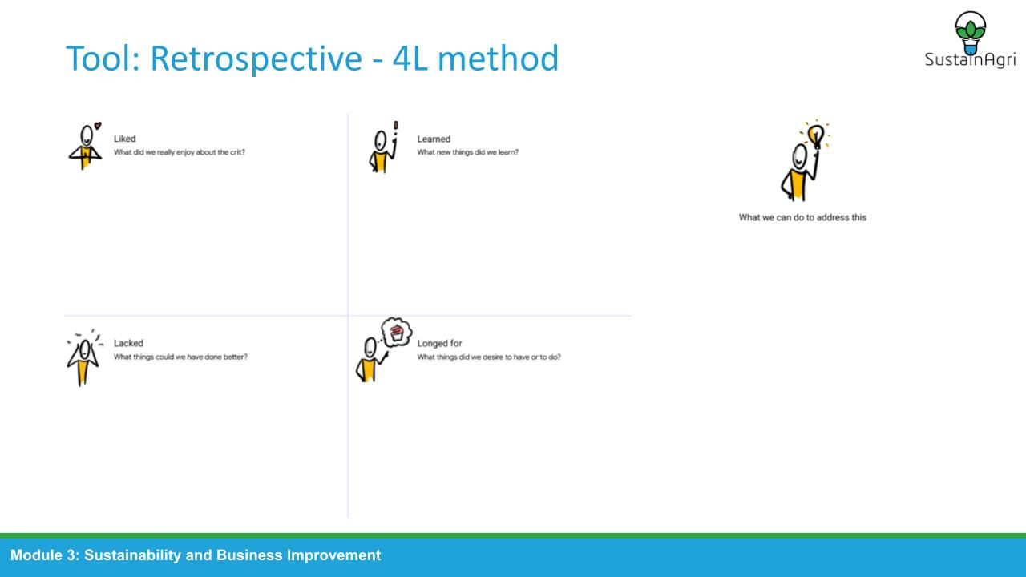

Notes:
(Self-)reflection is a crucial skill to improve yourself and your business in a sustainable way. The 4L method is one of the many methods that can be used to reflect. The special thing about the 4L method is that the reflection questions are formulated in an action oriented manner. A lot of our self- and group reflection tools lack the focus on an action that will solve the problem. The 4L method gives appreciation and attention to what went well, while also forcing the people involved to be critical, take action and make someone responsible.

Slide 16: | 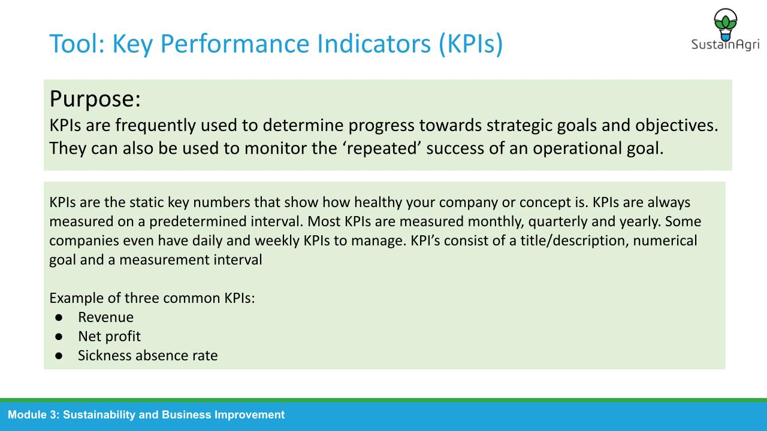

Slide 17: | 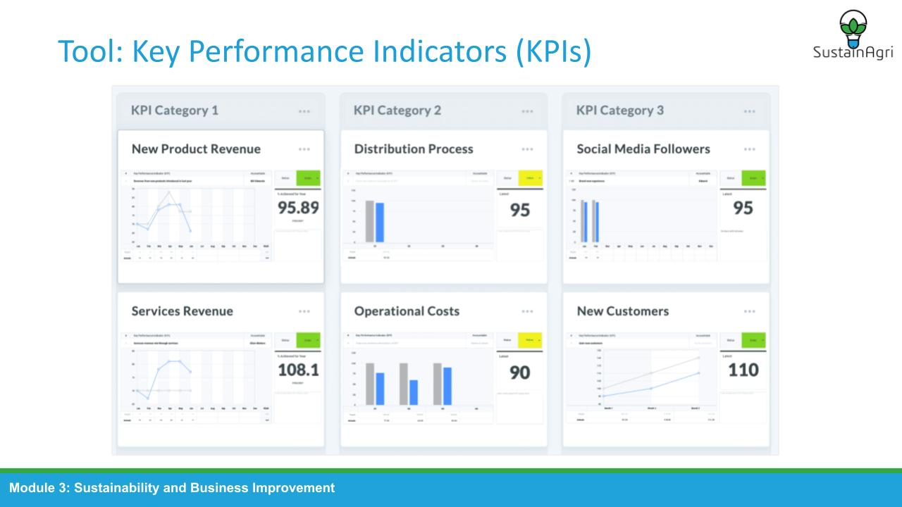

Notes:
KPI’s are often measured on a predetermined interval; daily, weekly, bi-weekly, monthly, quarterly, yearly and managed in either an Excel/Spreadsheet or specialized software. Don’t fall into the trap of creating too many KPIs for your company. While KPIs are really useful, they can quickly become a task on their own to manage. KPIs should save time and give you the right data to base your most important business decisions upon.
It is important for KPIs to be formulated in a SMART manner.
S Specific
M Measurable
A Achievable
R Relevant
T Time bound

Example ‘Bad’ KPI: We want to make enough money
Example ‘Good’ KPI: Return of Investment in Q1, 2021, Goal: €10.000+

Optional activity:
Have a (group) discussion about what would be the most important KPIs for a new business and what different KPIs you would have compared to an established business.

Slide 18: | 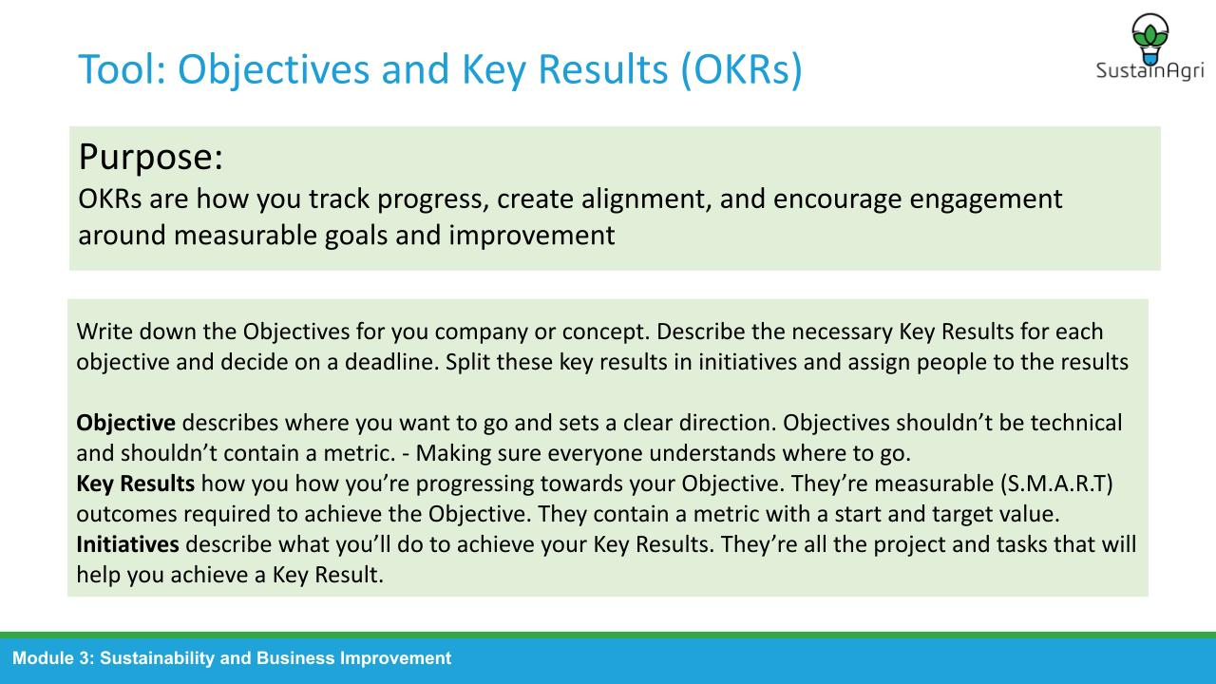

Slide 19: | 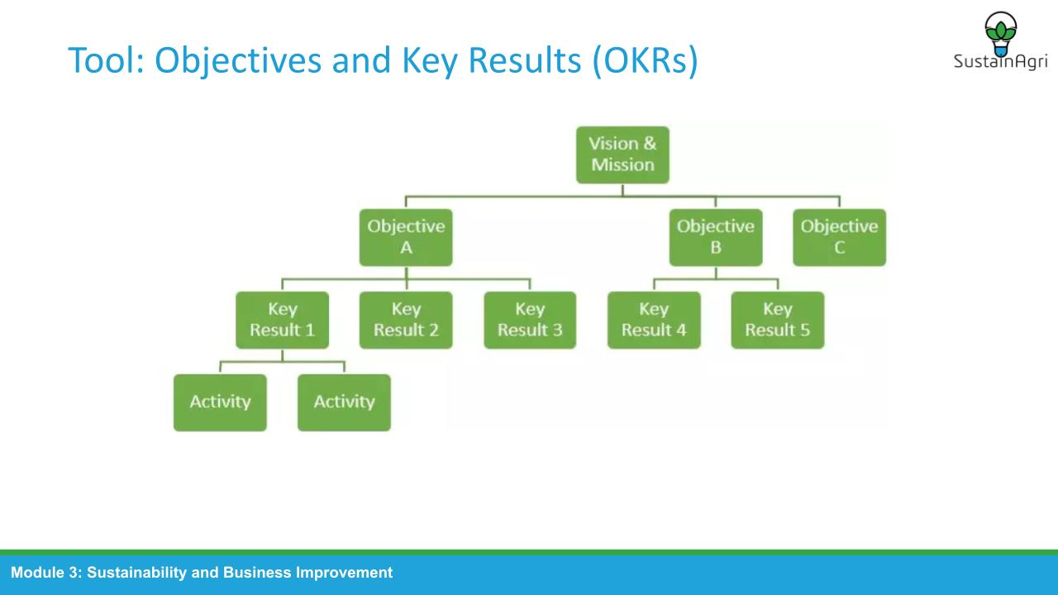

Notes:
With the OKR method, as an organization you choose to make results the driving force of everyone's work. If all activities contribute to achieving these results, you work together towards the common goal. You ensure that you are flexible while achieving your strategic goals. Good communication in this regard is essential. You do this by continuously evaluating and sharpening or adjusting your goals.
You choose goals per quarter. This makes the strategy flexible. Is there a major change within your company, your sector or in society? Then it is easy to adjust the strategy for the next quarter. You create clarity by breaking down your goals into small, measurable results. Everyone is always aware of the progress and priorities. This makes it easier to implement the strategy at every level.

Just like KPIs, OKRs should be formulated in a SMART manner
S Specific
M Measurable
A Achievable
R Relevant
T Time bound

Optional activity:
Have a (group) discussion about what would be the most important OKRs for a new business in their first year.

Slide 20:  Thank you. | 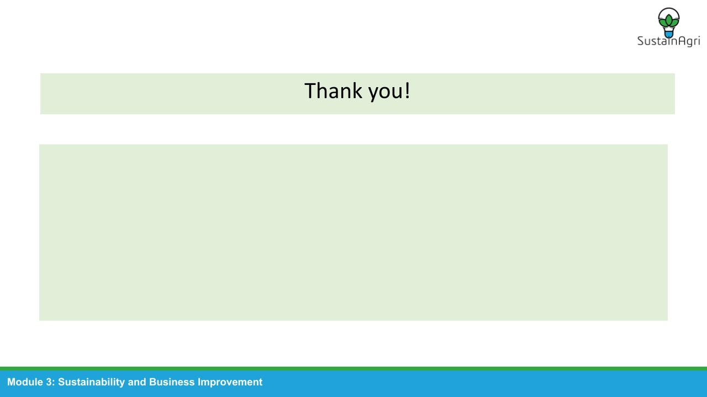

Notes:
Thank you for using SustainAgri module 3! Make sure to let the students know that by applying these tool in real life, they will find what works best for them.

